1️⃣ How Copilot Works as an Assistant for Applications
Think of Copilot as an AI layer embedded inside a specific application or ecosystem.

Core Idea
Copilot = Context-aware AI assistant tightly coupled with one app (or app suite)

Example: GitHub Copilot
Where it lives
- Inside VS Code / IDE
- Watches your code editor state
How it works
- Reads local context
  - Current file
  - Cursor position
  - Nearby functions
  - Imports, comments
- Sends this context to an LLM
- LLM predicts next best code
- IDE inserts suggestion inline
Key point
➡️ Copilot does NOT control apps
➡️ It augments what you are already doing

Example: Microsoft 365 Copilot
Where it lives
- Word, Excel, Outlook, Teams
What context it uses
- Current document
- Emails
- Calendar
- Permissions & tenant data (via Microsoft Graph)
What it can do
- Summarize document
- Generate slides
- Analyze Excel tables
- Draft emails
Architecture (simplified)
User Action
↓
App (Word / Excel)
↓
Copilot Plugin
↓
Microsoft Graph (data access)
↓
LLM (Azure OpenAI)
↓
Response injected back into app

Copilot Characteristics
✅ App-specific
✅ Deep native context
✅ Safe (permission-aware)
❌ Limited outside that ecosystem
❌ Not orchestration-heavy

2️⃣ How ChatGPT Works with Multiple Apps (Vibe Coding Style)
ChatGPT-style assistants are cross-application orchestrators, not just helpers.

Core Idea
ChatGPT = Central brain that talks to many tools, APIs, and apps
This is where vibe coding comes in.

3️⃣ What is “Vibe Coding”?
Vibe coding means:
- You describe intent
- AI figures out what to do
- AI coordinates tools
- You stay in conversation mode
Example:
“Add a KPI chart for packet loss and link it with alarm severity”
AI understands:
- EMS domain
- PM module
- KPI definitions
- Visualization
- Alarm correlation

4️⃣ ChatGPT Multi-App Architecture (Generic)
User (Chat UI)
↓
ChatGPT (LLM Brain)
↓
Tool / App Router
├── GitHub API
├── Jira
├── EMS APIs
├── Grafana
├── Database
└── Cloud / Scripts
↓
Actions + Results
↓
Natural Language Response

Key Difference from Copilot
Aspect | Copilot | ChatGPT (Vibe Coding)
Context | Single app | Cross-app
Scope | Assist | Orchestrate
Control | Suggest | Execute
State | Local | Global
Flow | Reactive | Intent-driven

5️⃣ ChatGPT with Multiple Apps: How It Actually Works

Step-by-Step
- Intent understanding
  - Natural language → structured task
- Task decomposition
  - “Create KPI”
  - “Fetch counters”
  - “Plot graph”
  - “Save config”
- Tool selection
  - EMS PM API
  - DB
  - Visualization service
- Execution
- Summarization
  - Human-readable response

6️⃣ Example: EMS Vibe Coding Assistant
User types:
“Show last 24h call drop KPI for Site-42 and highlight alarms”

What AI does internally
Intent:
- KPI: Call Drop Rate
- Time: Last 24h
- Object: Site-42

Actions:
- Query PM counters
- Calculate KPI
- Query FM alarms
- Correlate timestamps
- Generate chart

Result
- Chart
- Alarm overlay
- Explanation
- Suggested actions
➡️ This is NOT Copilot behavior
➡️ This is AI-as-Operator

7️⃣ Copilot vs ChatGPT in One Line
Copilot helps you do things better inside an app
ChatGPT helps you decide what to do across apps

8️⃣ When to Use Which?

Use Copilot when:
- Coding inside IDE
- Writing documents
- Doing repetitive app-specific tasks

Use ChatGPT-style Vibe Assistant when:
- Workflow spans multiple systems
- Domain logic matters (EMS, telecom, mining, 5G)
- You want decision + execution
- You want natural language control plane

9️⃣ For Your EMS Vibe Coding Assistant (Important Insight)
Your idea fits ChatGPT-style orchestration, not Copilot.
You are building:
- Domain-aware AI
- Northbound API controller
- Conversational EMS UI
- Intent → Network Action layer
In telecom terms:
Copilot = Smart CLI help
EMS Vibe Assistant = AI NOC Engineer

If you want, next I can:
- Design EMS Vibe Assistant architecture
- Map Copilot-like vs Vibe features
- Show how to implement tools / function calling
- Create a PRD or system diagram
Just tell me 👍
Design EMS Vibe Assistant architecture
Below is a clean, production-grade architecture for an EMS Vibe Assistant, designed exactly for your use case: Private 5G / Telecom EMS with intent-driven, multi-module orchestration.
I’ll explain it in layers, data flow, and deployment view, then give you a Mermaid diagram you can directly use in docs or GitHub Pages.

1️⃣ What EMS Vibe Assistant Is (1-Line Definition)
EMS Vibe Assistant = Conversational AI control plane that translates human intent into EMS actions across PM, FM, CM, and SM modules
It behaves like an AI NOC Engineer, not a chatbot.

2️⃣ High-Level Architecture Overview
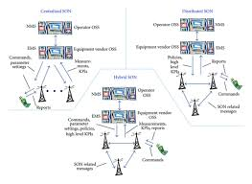
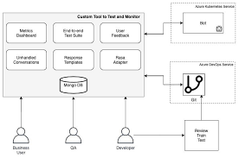

4

Core Principles
- LLM is NOT directly touching network
- All actions go via EMS APIs
- Domain rules + guardrails are mandatory
- Explainability + audit trail are first-class

3️⃣ Layered Architecture

🔹 Layer 1: User Interaction Layer
Channels
- Web EMS UI
- Chat Panel (inside EMS)
- CLI (optional)
- Voice (future)
Capabilities
- Natural language commands
- Follow-up questions
- Visualization embedding (charts, alarms)
User → “Show high packet loss sites and suggest action”

🔹 Layer 2: Conversation & Context Layer
Components
- Conversation Manager
- Session Memory
- User Role & Permission Context
- Site / Network Scope
Responsibilities
- Maintain multi-turn context
- Enforce RBAC (NOC L1, L2, Admin)
- Track what has already been done
📌 Example Context:
User: NOC-L2
Scope: Cluster-East
Time Range: Last 24h

🔹 Layer 3: Intent Understanding & Planning
This is the brain.

Components
- Intent Classifier
  - Query / Analyze / Configure / Predict / Explain
- Task Planner
  - Breaks intent into steps
- Domain Ontology
  - KPIs
  - Counters
  - Alarms
  - Network objects
Example
Intent: Analyze KPI degradation
Plan:
1. Fetch PM counters
2. Calculate KPI
3. Fetch correlated alarms
4. Rank affected sites

🔹 Layer 4: Guardrails & Policy Engine (Critical)
🚨 This layer protects your network
Checks
- Read vs Write operations
- Change window
- Impact radius
- Safety thresholds
- Regulatory rules
Example
“Restart gNodeB” → Blocked
Reason: Maintenance window closed

🔹 Layer 5: Tool & API Orchestration Layer
This is where “vibe coding” happens

Tool Types
Tool | Purpose
EMS PM API | KPI, counters
EMS FM API | Alarms
EMS CM API | Config changes
Inventory | Sites, cells
Analytics | ML inference
Visualization | Charts
Ticketing | Jira / ServiceNow
Execution Modes
- Read-only
- Simulated (dry run)
- Executed (approved)

🔹 Layer 6: EMS Core Modules

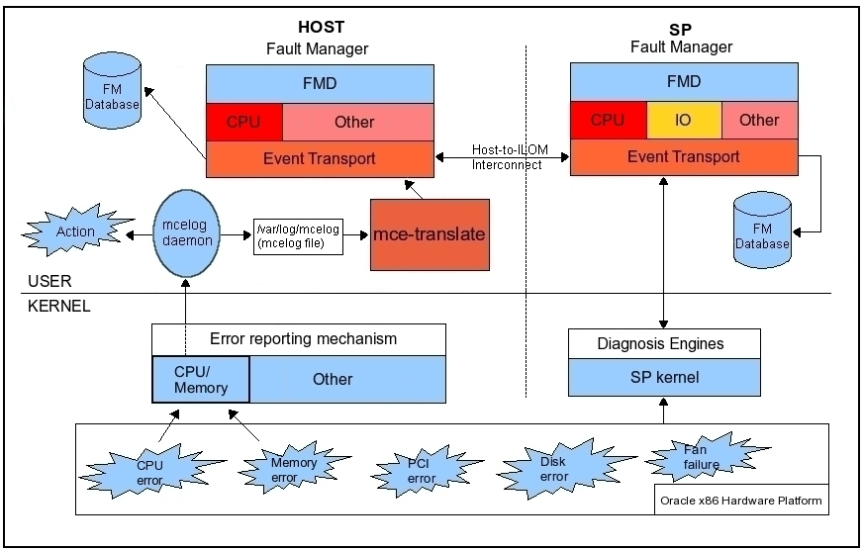
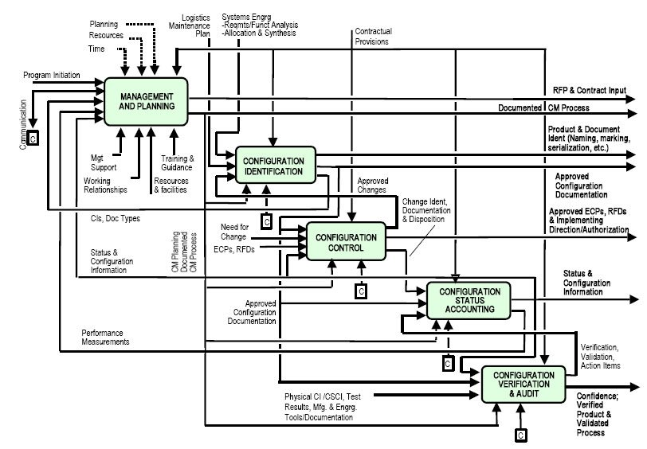
Module | Responsibility
PM | KPI, counters, trends
FM | Alarms, correlation
CM | Config, scripts
SM | Topology, inventory

🔹 Layer 7: AI / ML Services (Optional but Powerful)
Models
- Anomaly Detection
- KPI Forecasting
- Root Cause Analysis
- Risk Scoring
Example
Prediction: Site-42 packet loss will cross SLA in 2 hours
Confidence: 92%

🔹 Layer 8: Response & Explainability Layer
Outputs
- Natural language explanation
- Charts & tables
- Recommended actions
- Confidence score
- Audit log
Example
“Packet loss increased due to congestion on backhaul link. Suggested action: increase scheduler weight.”

4️⃣ End-to-End Data Flow
User Intent
↓
Conversation Context
↓
Intent Classification
↓
Task Planning
↓
Policy Validation
↓
Tool Orchestration
↓
EMS Modules
↓
AI Analysis
↓
Explanation + Visualization

5️⃣ Mermaid Architecture Diagram (Ready to Use)
flowchart TB
%% ===== User Layer =====
User["👤 User<br/>(EMS UI / Chat / CLI)"]

%% ===== Interaction Layer =====
Chat["💬 Conversation Manager<br/>& Context"]

%% ===== Intelligence Layer =====
Intent["🧠 Intent Understanding"]
Planner["📋 Task Planner"]
Policy["🛡️ Policy & Guardrails"]

%% ===== Orchestration Layer =====
Orchestrator["🔧 Tool & API Orchestrator"]

%% ===== EMS Core =====
subgraph EMS["📡 EMS Core"]
PM["📊 Performance Mgmt (PM)"]
FM["🚨 Fault Mgmt (FM)"]
CM["⚙️ Config Mgmt (CM)"]
SM["🗺️ Inventory / Topology (SM)"]
end

%% ===== AI Services =====
AI["🤖 AI / ML Analytics"]

%% ===== Response =====
Response["📈 Visualization & Explanation"]

User --> Chat
Chat --> Intent
Intent --> Planner
Planner --> Policy
Policy --> Orchestrator

Orchestrator --> PM
Orchestrator --> FM
Orchestrator --> CM
Orchestrator --> SM

PM --> AI
FM --> AI
AI --> Response
Response --> User

6️⃣ Deployment View (Realistic)

Recommended Stack
Layer | Tech
Frontend | React + Chat UI
Backend | FastAPI / Node
LLM | OpenAI / Azure OpenAI
Memory | Redis
APIs | REST / gRPC
Auth | Keycloak / OAuth
Observability | Prometheus
Audit | Elastic / DB

7️⃣ Why This Architecture Will Scale
✅ Multi-vendor EMS
✅ Safe for live networks
✅ Works for Private 5G, LTE, Wi-Fi
✅ Extendable to SON / rApps / xApps
✅ Enterprise-ready

8️⃣ Next Steps (Suggested)
If you want, I can next:
- Create PRD for EMS Vibe Assistant
- Define Tool contracts (JSON schemas)
- Design Intent taxonomy
- Map Feature → KPI → ROI
- Create Investor / client demo flow
Just tell me which one you want next 🚀

